**Project Report**

**On**

**“Hotel Five Star”**

Submitted for partial fulfilment of requirement for the degree of bachelor of

Engineering

In

**Information Technology**

**by**

**Nayana Lokhande**

Under the guidance of

**Prof. Miss. S. R. Kamble**

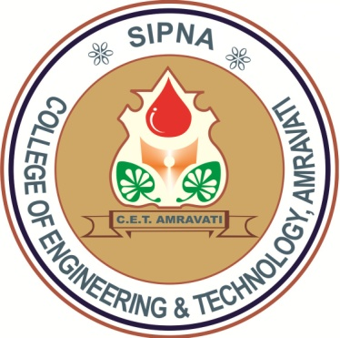

Department of Information Technology

Sipna college of Engineering and Technology , Amravati

(An ISO 9001:2008 certified)

SantGadge Baba Amravati University , Amravati

2015-2016

**Certificate**

This is certify that the Project entitle

**“Hotel Five Star”**

It Bonafied work and it is submitted to the sant Gadge Baba Amaravti

University , Amravati

By

**Nayana Lokhande**

In partial fulfilment of partical on CLAB(HTML)for Bachlor Degree of Engineering in

The Information Technology Semester Fourth during the Academic year 2015-2016 under by

Guidance



Prof. S. R. KAMBALE Dr. V. S. GULHANE

(Project Guide) (H.O.D)

**Department of Information Technology**

**Sipna college of Engineering and Technology**

(An ISO 9001:2008 certified)

**Santgadge baba Amravati University,Amravati**

2015-2016

ACKNOWLEDGEMENT

We wish to express our sincere gratitude to **Prof. S.R. Kamble** For her exemplary guidance , monitoring andconstant encouragement for **“Hotel Five Star”**. Wewould also take this opportunity to express a deep sence ofgratitude to our Head Of Department a **Dr. V.S. Gulhane** for his co-ordial support , valuable information and guidance.

**Nayana Lokhande**